**Supplementary Requirements - Release 2**

1. **FV - Field Validation**

1.1 Field “Comment”

**Scope:**

* UC05.01 Ticket Submission

**Requirements:**

* Field should be mandatory - the user should not be able to submit the ticket without entering the comment

**Conditions to Apply:** After the respective join points

1.2 Field “Review”

**Scope:**

* UC06.01 Leave Review

**Requirements:**

* Field should be mandatory - the user should not be able to leave blank review

**Conditions to Apply:** After the respective join points

1. **CN - Connectivity**

**Scope:**

* UC03.04 Order cancel/history
* UC05.01 Ticket submission
* UC05.02 Ticket history/resolution
* UC06.01 Leave review

**Requirements:**

* If no internet connectivity the application should not be displayed
* If no internet connectivity the error message should be displayed: “Please check your network connection and/or reload the page.”

**Conditions to Apply:** Before the respective join points

1. **DDV - Data-Driven Defaults**

**Scope:**

* UC05.01 Ticket Submission
* UC06.01 Leave Review

**Requirements:**

* The name should be populated on the Name field, same exact name that is entered in the Account Info page
* The email should be populated on the Email field, same exact email that is entered in the Account Info page

**Conditions to Apply:** After the respective join points

1. **DF-In - Data Flow In**

**Scope:**

* UC03.04 Order cancel/history
* UC05.01 Ticket Submission
* UC05.02 Ticket history resolution

**Requirements:**

* The order should be placed by the customer and processed by the system, to exist in the database, so that it can be displayed on order history page and cancelled
* The Name and email should flow in from the Account Info page
* The ticket should be submitted by the customer and processed by the system, to exist in the database, so that it can be displayed on ticket history resolution page and display the status

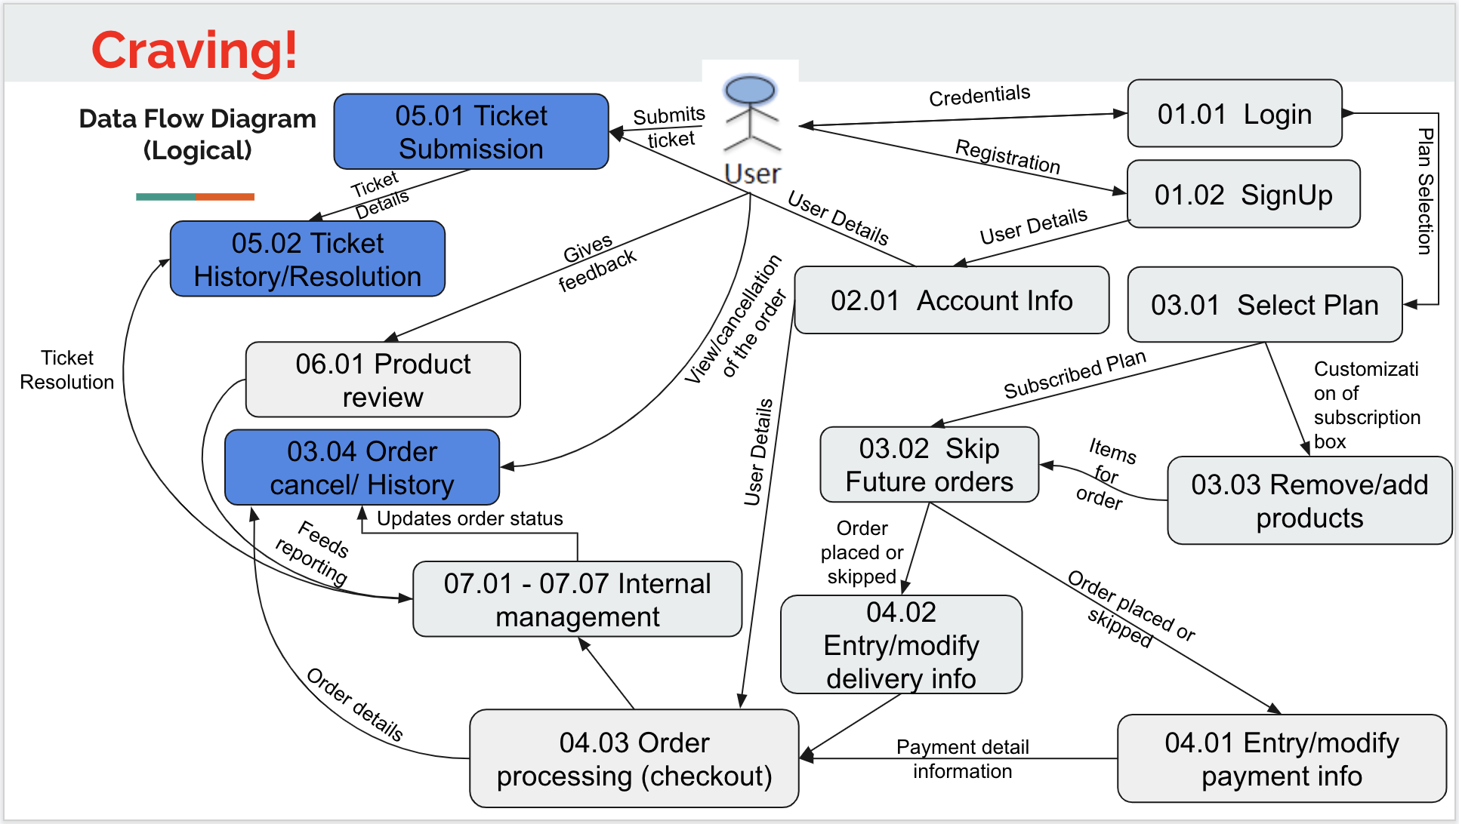

**Conditions to Apply:** After the respective join points

1. **DF-Out - Data Flow Out**

**Scope:**

* UC05.01 Ticket Submission

**Requirements:**

* The data on the submitted ticket should flow to the 05.02 Ticket history/resolution page, and should display the same exact information that was displayed on the submitted ticket

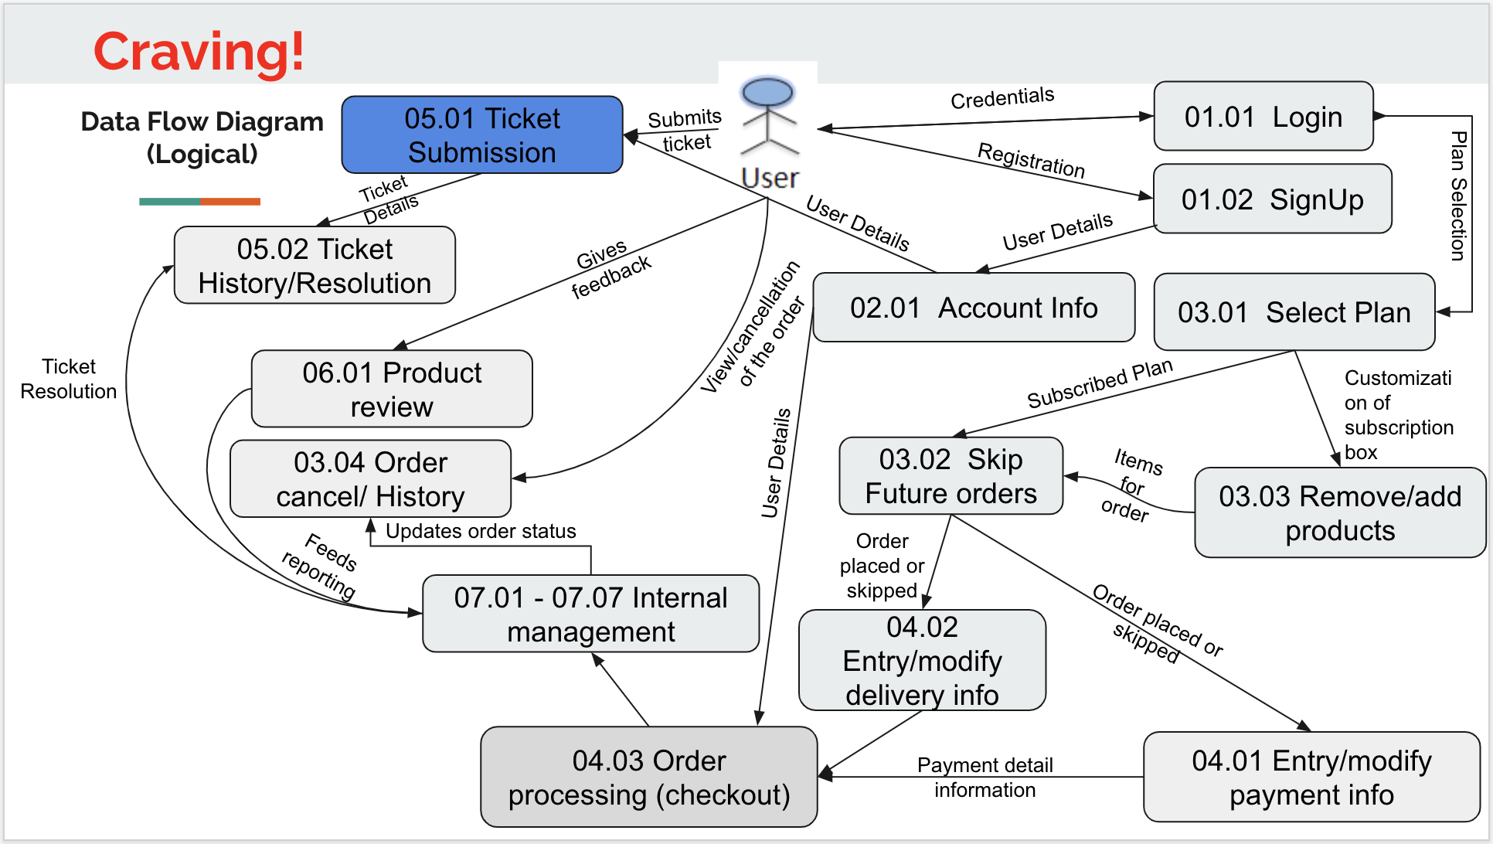

**Conditions to Apply:** After the respective join points